|  |  |
| --- | --- |
| SOP ID - Number | **HR02-P01** |
| Revision | **5** |
| SOP Title | **Medical Insurance** |

|  |  |  |  |  |
| --- | --- | --- | --- | --- |
|  | Name | Title | Signature | Date |
| Prepared by | Bashar Haddad | HR Specialist |  | 14/01/2024 |
| Reviewed by | Zaid Ibrahim | HRBP |  | 16/01/2024 |
| Approved by | Bishara Shemali | S.HR MAnager |  | 16/01/2024 |

|  |  |  |
| --- | --- | --- |
|  | **Effective Date** |  |
|  | **Review Date** |  |
|  | **Next Review Date** |  |
|  | **Print Date** |  |

|  |  |  |  |
| --- | --- | --- | --- |
| **Read/Used By** | | | |
| **Name** | **Title** | **Signature** | **Date** |
|  |  |  |  |
|  |  |  |  |
|  |  |  |  |
|  |  |  |  |
|  |  |  |  |
|  |  |  |  |
|  |  |  |  |
|  |  |  |  |

1. **purpose**

Wuduh is committed to providing comprehensive medical insurance to eligible employees, ensuring access to quality healthcare services that promote their well-being. The policy aims to reduce the financial burden of medical expenses for employees and their families, encourage timely access to necessary healthcare, and reinforce the company’s dedication to employee welfare. This reflects Wuduh's broader mission to create a supportive and inclusive work environment while adhering to local regulations and industry best practices

1. **Scope**

This Policy and Procedure applies to all employee of Wuduh and New Joiners including their families.

1. **Policy**

**Medical Insurance “MI” Online Form:**

* All the employees must submit the MI enrollment form within 48 hours, or the HR will provide another active link with the next enrollment process within 7 days.
* Medical cards will be received back from the medical provider within 5 days of submission.
* Medical insurance policies orientation must be part of the HR induction presentation.

**Required Documents & Declarations:**

* Family book must be submitted during onboarding.
* Spouse and children can only be added after enrollment in cases of marriage (with a marriage certificate) or during the annual renewal.
* Previous medical conditions must be declared at the time of enrollment; future related claims will not be covered if not declared.
* Employees must provide documentation from their previous insurance provider to confirm the end date of their prior coverage.
* Employees with the same insurer as Wuduh have the option to cancel their active insurance to submit a new request with continuity and moved under Wuduh’s plan (if applicable).

**Medical Coverage for Marriage and Newborns:**

* Newly married employees must provide the family book within 15 days to add the spouse.
* Health insurance coverage for the wife is provided upon proof of marital status and at the employee's request.
* The female employee is not covered under the health insurance system if her husband works for another organization that provides medical services at the same level as the company.
* If the female employee wishes to include her husband in the health insurance, she must provide proof that he is not benefiting from any other insurance
* Newborns will be covered under the mother's insurance for the first 15 days and must provide a request to the insurance through HR to cover the newborn if the employee is eligible to cover their dependents.

**Eligibility for Coverage:**

* Operations Functions (Entry to Mid-Level): Full-time employees who have completed the probation period are eligible for insurance.
* Manager Level & Above: Eligible for insurance from day one at Wuduh.
* Support Functions: All employees are eligible from day one at Wuduh.

**Dependents Coverage:**

* Support Departments, as well as Supervisors and above in Operations Departments: Eligible to include spouse(s) and children at no cost:
  + Spouse(s) as legally recognized.
  + Children up to 24 years old if enrolled in full-time education, Up to 3 children, The employee will cover the MI cost of any additional dependents, and will be deducted from the employee monthly payment or as the HR manager recommends.

**Coverage Levels:**

* Directors & Above: Additional benefits based on the active insurance policy.
* Managers & Below (Class A): Standard coverage.
* Exceptions: Must be approved by the Head of HR.
* Extra Benefits: Additional benefits like dental and optical coverage as per the insurance policy.
* Temporary or Freelance Workers: Not eligible for medical insurance unless stated otherwise in their contract.
* **Reimbursement**: Only available for active insured members and subject to required documents being submitted through the portal.

1. **Definitions AND ABBREVIATION**

* HR: Human Resources
* HRS: Human Resources Specialist
* MI: Medical Insurance
* DS: Direct Supervisor
* MD: Managing Director
* SF: Support Functions
* PP: Probation Period

1. **ROLES AND responsibilities**

**HR Manager**

* **Conduct Annual Provider Evaluation:** Oversee the annual review of medical insurance providers, comparing services, coverage options, and pricing to ensure Wuduh secures the best deal. This includes gathering performance data, evaluating feedback, and negotiating competitive terms.
* Responsible for ensuring that Wuduh partners with the best medical provider to cover its employees and for overseeing the prompt and efficient implementation of this policy across the organization.

**HRS**

* **Oversee the Medical Insurance Program:** Ensure the effective implementation and maintenance of the medical insurance policy for all eligible employees in line with company standards and regulations.

**HR Admin Assistant**

* Receive and distribute the Medical Cards to the employee(s) / DS accordingly and obtain receipt signatures
* Maintain records of insurance proposals and documents.
* Distribute official communications to employees about the chosen provider.
* Collaborate with HR and HRS teams to ensure smooth execution of the medical insurance enrollment process and ongoing employee support.

**In-House Doctor/Safety Officer:**

* **Employee Health & Medical Care:**
  + Conduct health checkups and maintain records.
  + Provide first aid and emergency care for workplace injuries or illnesses.
  + Offer medical consultations and refer employees for follow-ups.
  + Grant sick leave when deemed medically necessary and issue corresponding reports.
* **Workplace Safety & Emergency Response:**
  + Act as the first point of contact for workplace medical emergencies.
  + Ensure compliance with health & safety policies and medical regulations.
* **Sick Leave & HR Coordination:**
  + Evaluate sick leave requests and issue medical reports.
  + Approve or reject sick leave per HR policies and medical necessity.
  + Maintain sick leave records and report trends to HR.

1. **SPECIFIC PROCEDURE**

**6.1 Insurance Provider Approval Process**

**6.1.1 Identification of Insurance Providers**  
The Human Resources Department will reach out to health insurance companies to obtain detailed insurance proposals for review. These proposals will be studied thoroughly, and the most suitable option will be selected based on several criteria. The department will also gather and document essential information about each provider, including their reputation, network of accredited healthcare providers, credibility, financial cost, number of approved medical institutions, geographical coverage, and the full scope of coverage offered by the policy.

**6.1.2 Financial Review and Recommendations**  
The Finance Manager will assess the financial impact of the proposed insurance options on the company and provide recommendations. The recommendations will be carefully considered considering the company’s budgetary constraints and the needs of the employees.

**6.1.3 MD Endorsement**   
According to the HR & Finance Department Recommendations.

**6.1.4 Communication and Documentation**  
Human Resources Department will distribute a memo which includes the name of the selected insurance provider, along with all necessary details regarding the policy, including coverage options and conditions. The memo will be shared with all employees, ensuring they have the information required to utilize the health insurance benefits.

* 1. **Medical Insurance Enrollment Procedure for New Joiners**

**6.2.1 Initial Steps After Joining Orientation**

Once the employee is eligible to the MI benefits

* + - HRS inputs the employee's details into the MI portal.
    - The MI portal sends the enrolment forms to the employee’s email.
    - Employee completes and submits the forms. **“Within 48 hours”**

**6.2.2 Verification and Follow-up**

HR will send a reminder to the employee who didn’t submit the MI form “if needed” as the below workflow chart.

* + 1. **Confirmation of Successful Listing**
* HRS investigates the MI Portal to determine whether the issue is due to non-submission or an error in the declaration form submission and resolves it as the below workflow.
* HRS issues a manual medical form to be filled by the employee, and submits it to the MI provider, if his application has declaration issues.

**6.2.4 MI Card Distribution**

* **HR Admin Assistant receives the MI cards within 5 business days**:

The admin assistant will manage distributing the MI cards and receive the employee’s signatures.

**6.3 Sick Leave Approval Process & System Access**

* The inhouse Doctor/Safety Officer is designated as the first line of contact for medical matters.
* The inhouse Doctor has the authority to approve sick leaves exclusively.
* Employees must provide the necessary documentation to the Doctor for assessment before HR processes the leave.

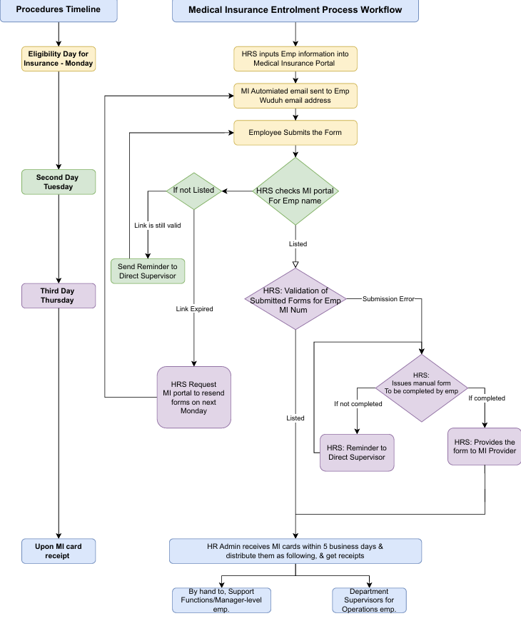

**forms/Templates to be used**

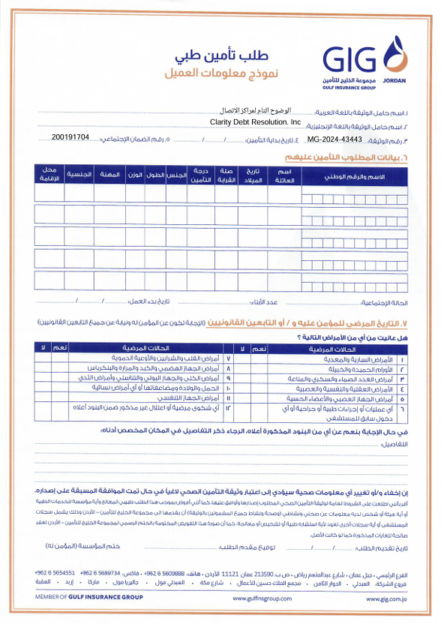

**documentations AND RECORDS**

**internal and external references**

**Legal and Regulatory Compliance**

**Documentation and Records**

**REVISION AND Change History**

| **SOP No.** | **Effective Date** | **Significant Changes** | **Previous SOP No.** |
| --- | --- | --- | --- |
|  |  |  |  |
|  |  |  |  |
|  |  |  |  |
|  |  |  |  |